1/run report ZKCT_ABAP_DOC

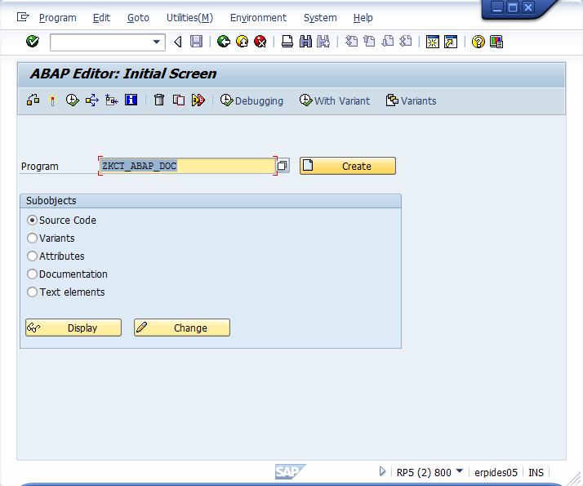

2/select objects to be processed and output options on the selection screen:

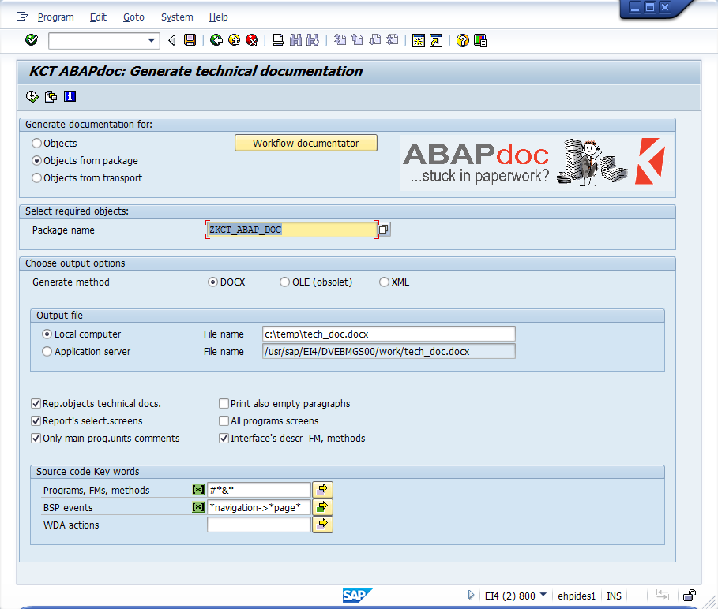

3/select individual objects to be included in the output document:

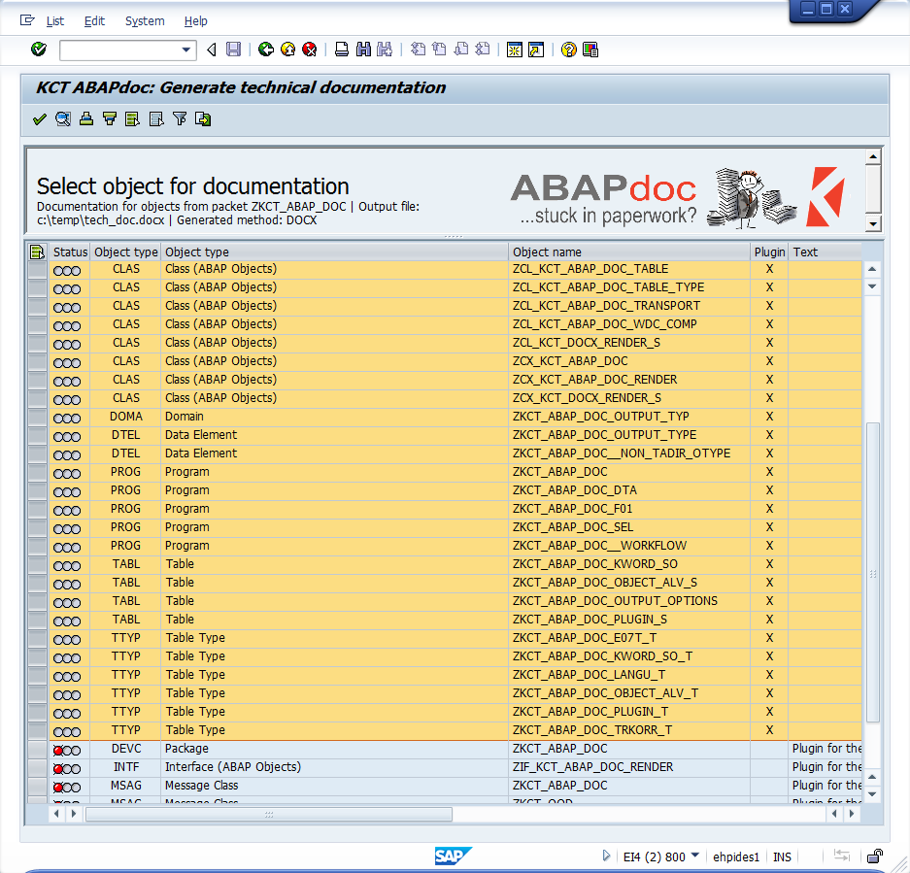

4/output DOCX document is generated ( successfully processed objects marked by green).

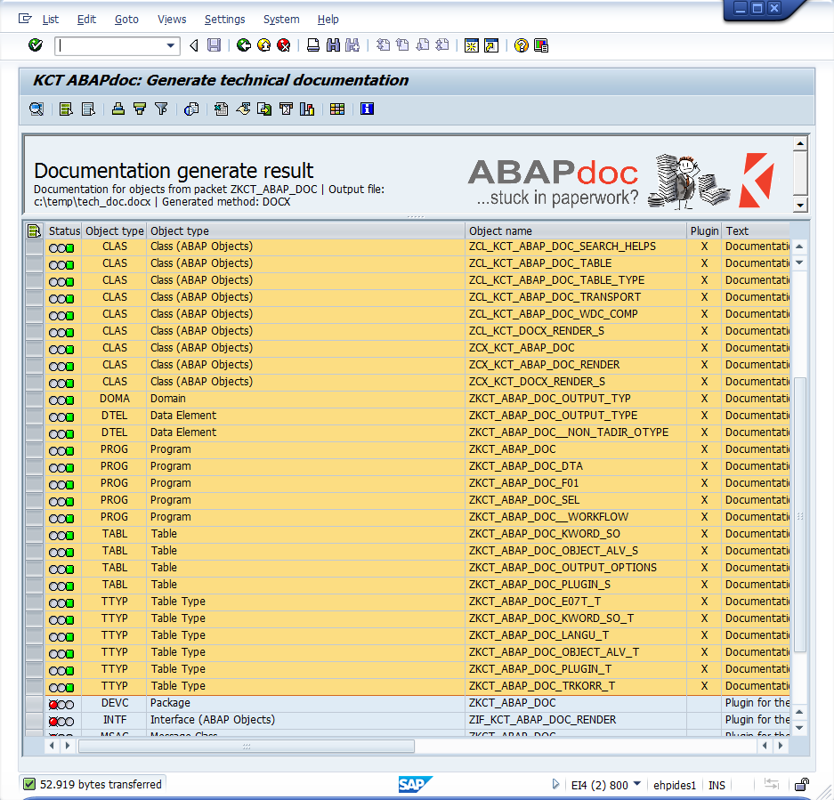

The ABAPdoc package quick-view:

